Ex. No. 9 – Use Process Explorer to Identify Suspicious Processes
Aim: To use Microsoft Sysinternals Process Explorer to examine running Windows processes and identify potentially suspicious processes by checking process details, executable path, digital signature, registered services, CPU usage, and memory usage.
Tools Required: Windows 10/11; Microsoft Sysinternals Process Explorer.
Procedure
Step 1: Launch Process Explorer
Microsoft Sysinternals Process Explorer was downloaded and extracted. The procexp64.exe application was opened to display the processes currently running on the Windows system.
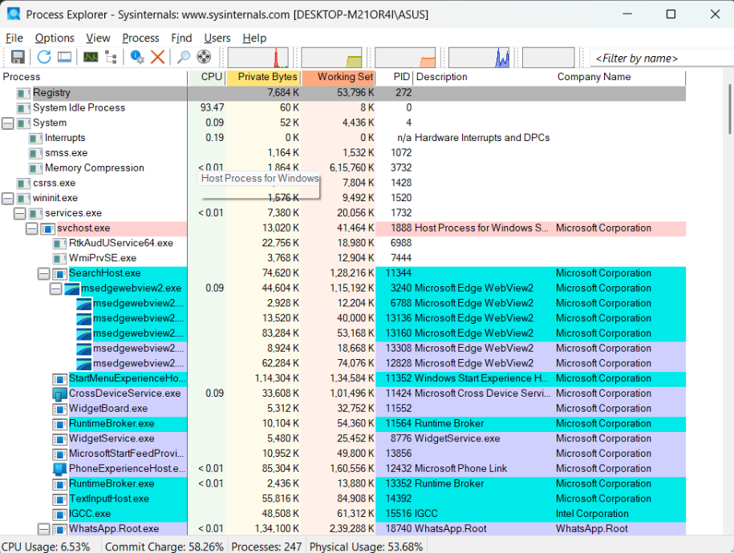
Step 2: View Running Processes
The main Process Explorer window displayed active processes in a hierarchical process tree. The available information included Process Name, CPU Usage, Private Bytes, Working Set, Process ID (PID), Description, and Company Name.
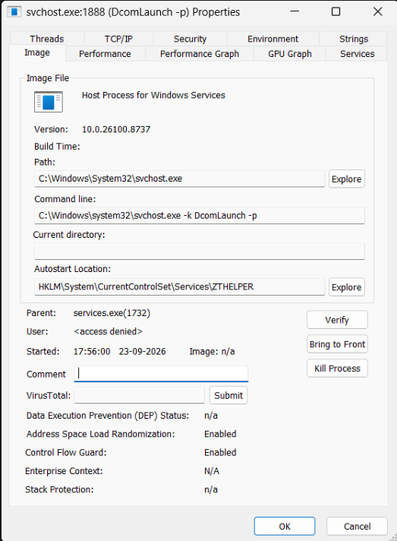
Step 3: Select a Process
The svchost.exe process with PID 1888 was selected for detailed examination. The process was displayed under the parent process services.exe.
Step 4: Check Process Properties
The Properties window of svchost.exe was opened to examine its process information.
Process | svchost.exe
PID | 1888
Description | Host Process for Windows Services
Version | 10.0.26100.8737
Path | C:\Windows\System32\svchost.exe
Parent | services.exe (1732)
Command Line: C:\Windows\system32\svchost.exe -k DcomLaunch -p
Ex. No. 9 – Process Examination (Continued)
Step 5: Verify Digital Signature
The digital signature of the selected process was checked using the Verify option in the Properties window. The result displayed “(Verified) Microsoft Windows Publisher”, indicating that the executable was verified as being published by Microsoft Windows.
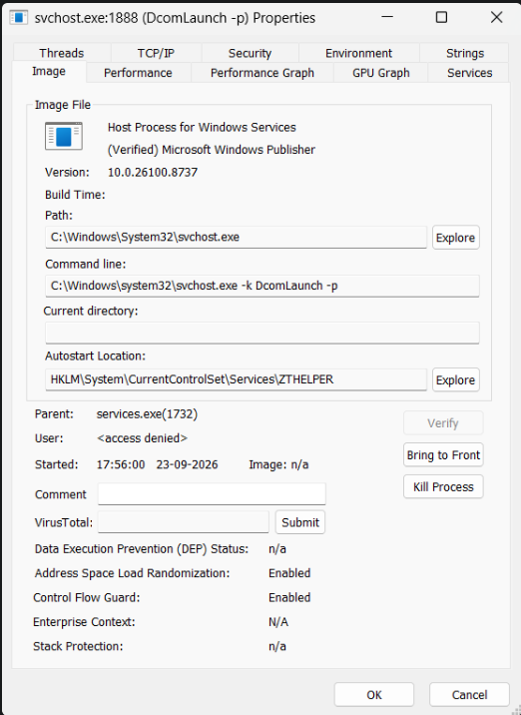
Step 6: Check Registered Services
The Services tab was opened to examine the services associated with the selected svchost.exe process.
Service | Display Name
BrokerInfrastructure | Background Tasks Infrastructure Service
DcomLaunch | DCOM Server Process Launcher
PlugPlay | Plug and Play
Power | Power
SystemEventsBroker | System Events Broker
The associated service paths were located under the Windows System32 directory.
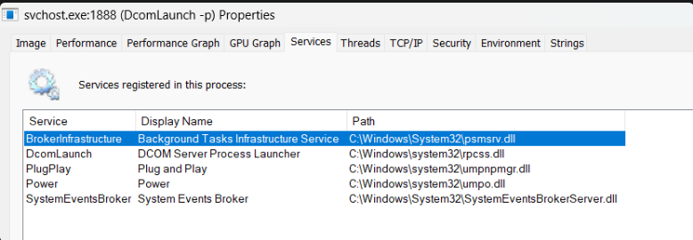
Step 7: Observe CPU and Memory Usage
The Process Explorer main window was examined to observe the resource usage of the selected process. The approximate values recorded for svchost.exe were:
CPU | <0.01%
Private Bytes | 13,024 K
Working Set | 41,516 K
PID | 1888
Company Name | Microsoft Corporation
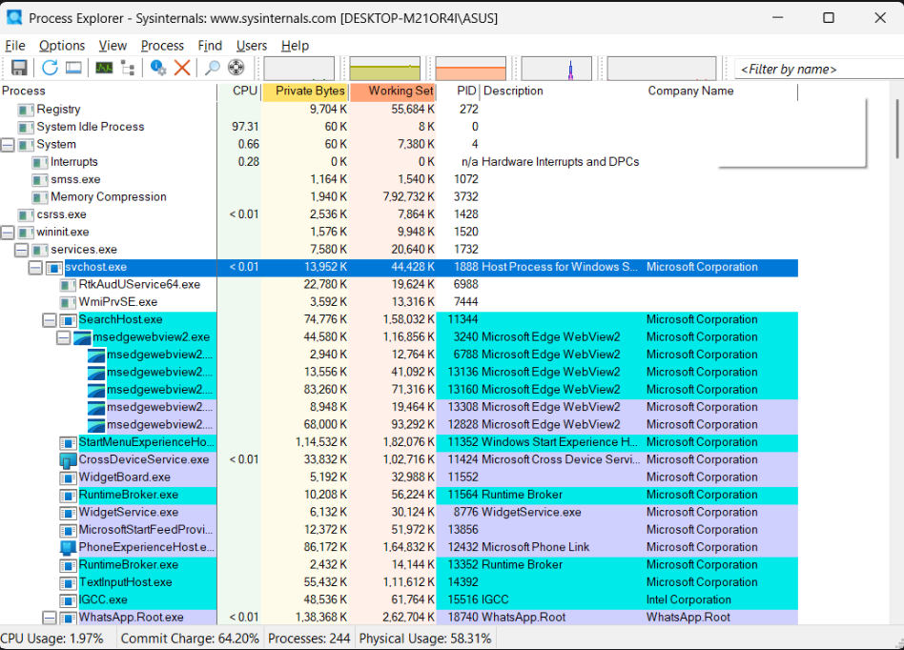

Ex. No. 9 – Process Analysis and Result
Step 8: Analyze the Process
The selected svchost.exe process was analyzed using its process name, executable path, parent process, digital signature, company name, registered services, CPU usage, and memory usage. The executable was located at C:\Windows\System32\svchost.exe and was verified as Microsoft Windows Publisher. The process was also associated with standard Windows services. Based on the characteristics observed during the examination, no obvious suspicious indicators were identified.
Step 9: Process Control Options
The context menu of the selected process was opened. The available options included Kill Process, Kill Process Tree, Restart, Suspend, and Create Dump.
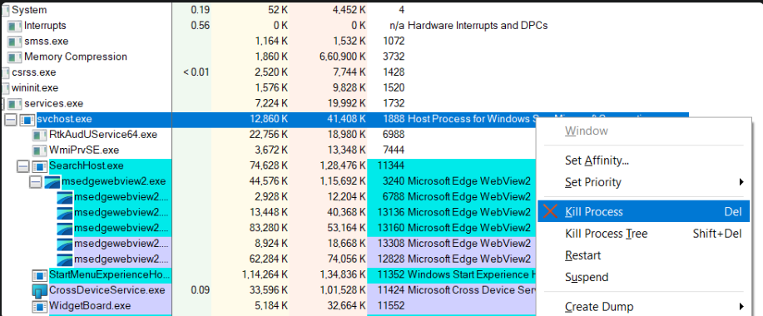
The Kill Process option was not used because the examined svchost.exe process did not show any obvious suspicious indicators. It had a verified Microsoft Windows publisher signature, was located in the Windows System32 directory, and was associated with standard Windows services. Therefore, terminating the process was not necessary for this experiment.

Observation
The svchost.exe process with PID 1888 was examined using Microsoft Sysinternals Process Explorer. Its process details, executable path, digital signature, parent process, registered services, CPU usage, and memory usage were checked. The process was located in the Windows System32 directory and was verified as Microsoft Windows Publisher.
Result
Microsoft Sysinternals Process Explorer was successfully used to examine a running Windows process and identify potential suspicious indicators. The examined svchost.exe process showed characteristics consistent with a legitimate Windows system process, and no obvious suspicious indicators were observed during the examination.

